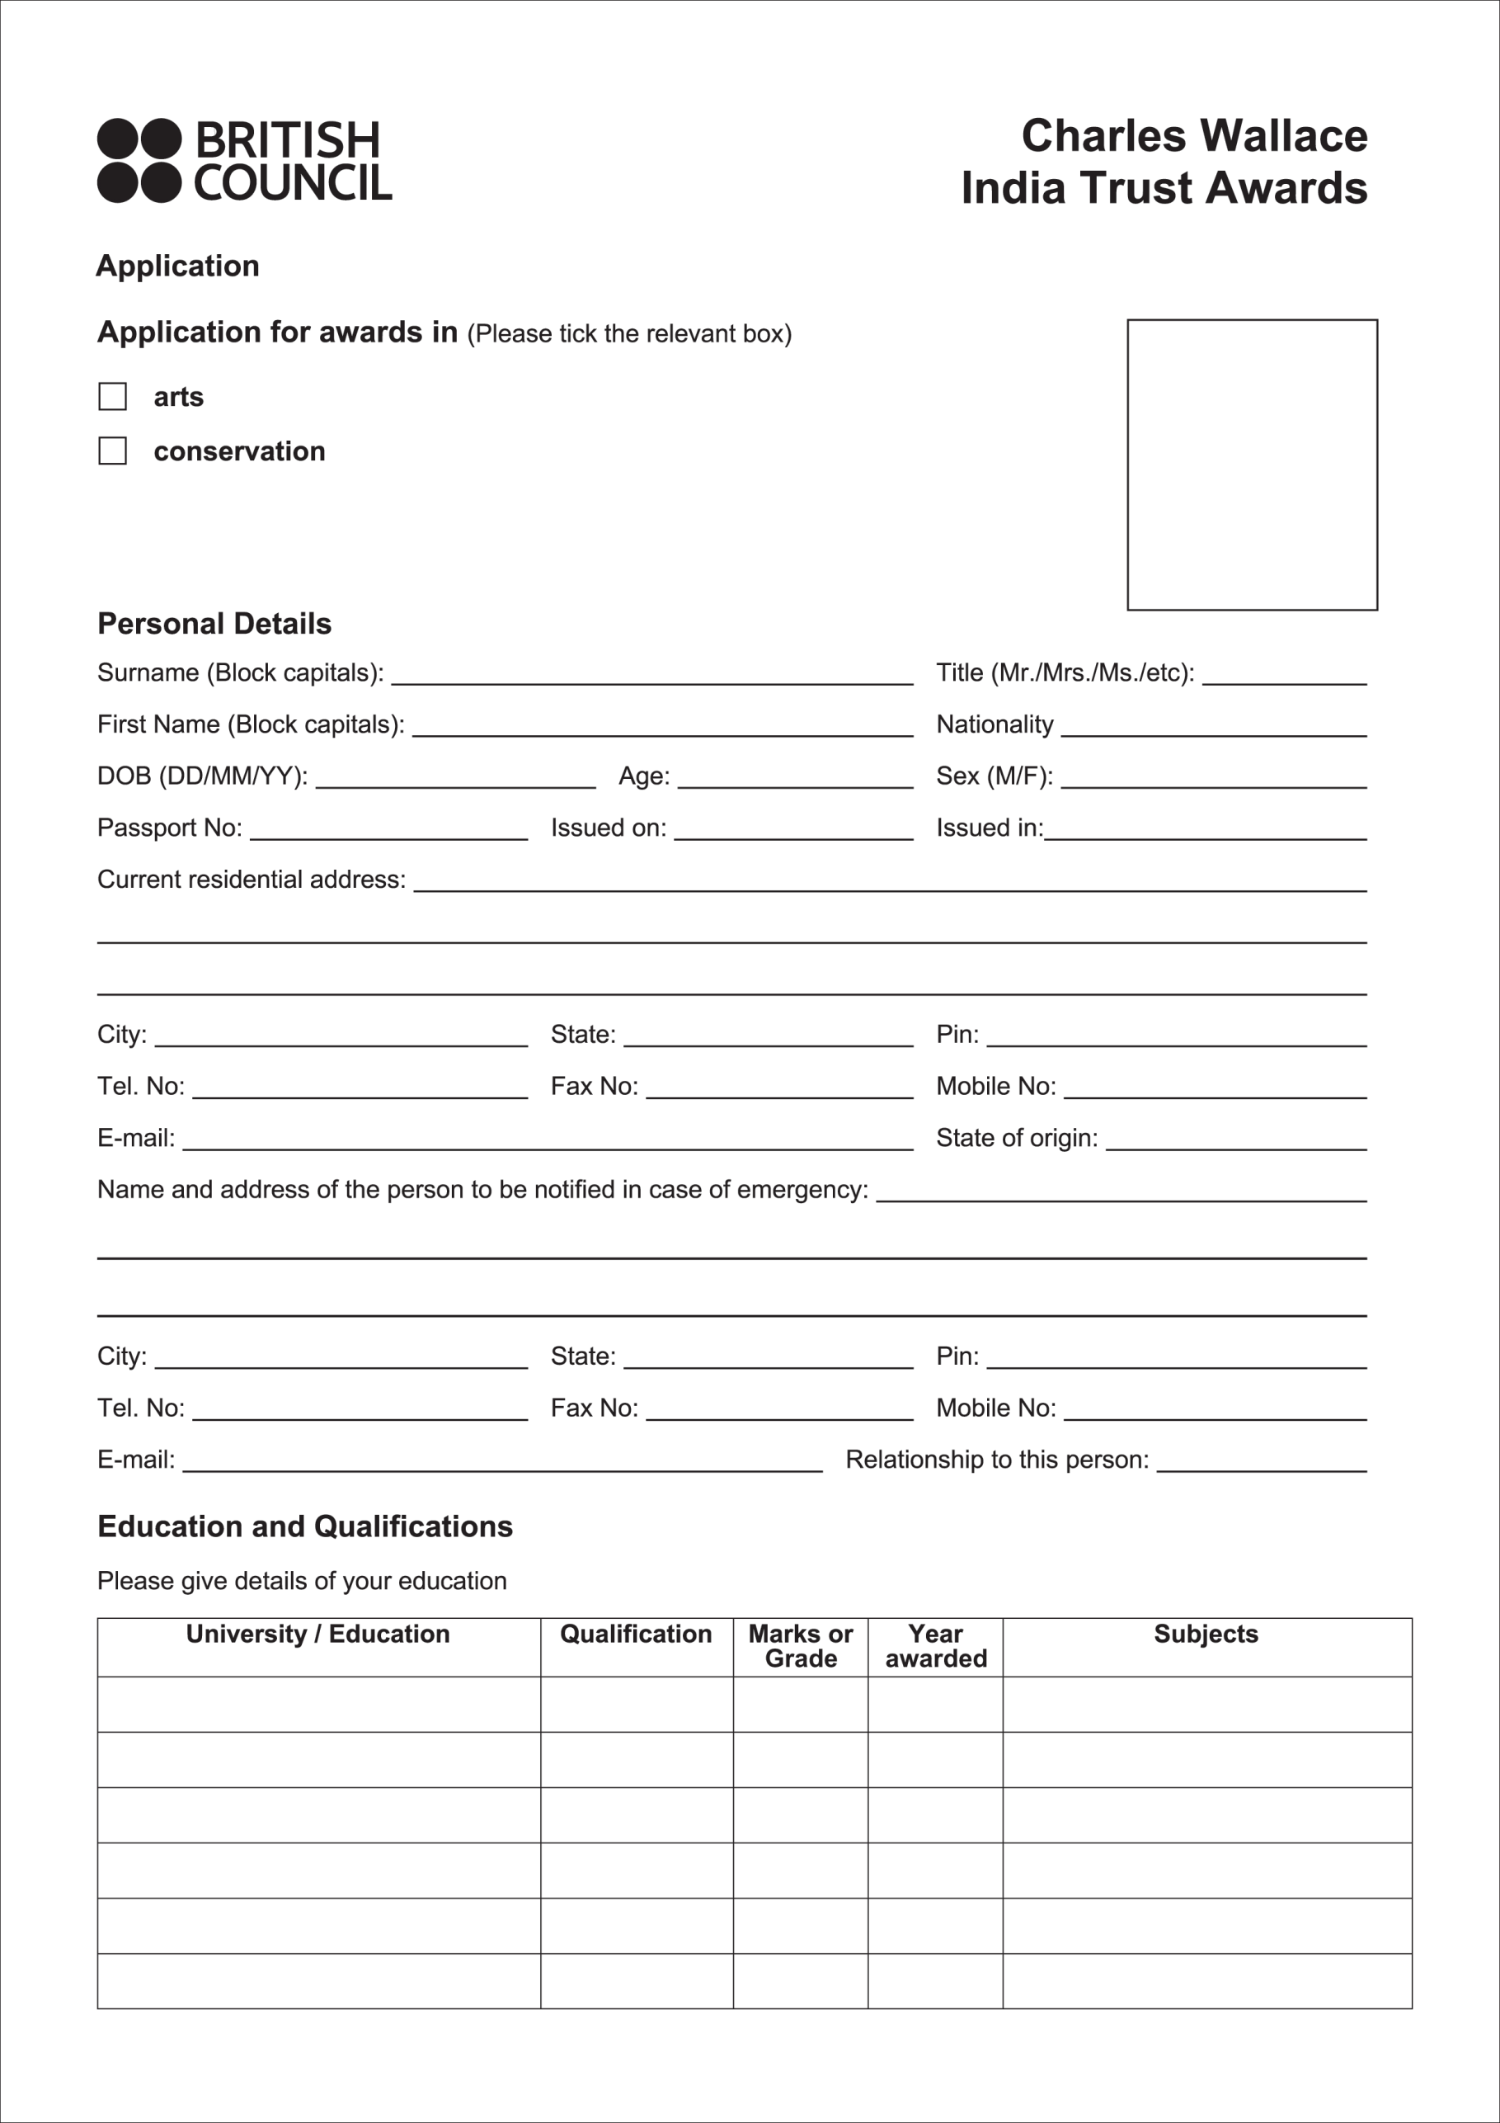

form for Long term Scholarships – 2019-20
Experience and Employment

Present Occupation: -------------------------------­
Name, designation and address of employer: -----------------------

City: ---------­

Tel. No: ----------
State: --------- Pin: ------------
Mobile No: _ E-mail:-----------

Details of previous experience (Please list in chronological order starting with the most recent work and attach upto six samples of your work or portfolio, if applicable)

If in employment, will you be released for the proposed study I stay in the UK? Please attach evidence:

References: Name two persons with their designations and contact details (address, mobile, e-mail) who are familiar with your work:
1. _ 2.

Statement of Purpose

Please take great care over this section as it will be very influential in reaching a decision about your application. Use separate A4 sheets (upto two) if you wish and state clearly the following:
• The purpose of your proposed study/attachment
• The specific area on which you want to concentrate
Where you want to study/be attached and why. If you want to follow a set course of study please specify both the course and the institution.
• Describe how you intend to use your newly acquired skills/experience when you return to India

Please give details of the UK institution/sat which you have secured a place or to which you have applied. Please attach evidence if you have secured a place:

Duration of the proposed training/attachment/study. Please specify:

Precedence will usually be given to applicants who have secured appropriate places at UK institutions.

Other Details

Have you visited the UK before? If so, for what purpose? Please give details:

Have you previously received or applied for a Charles Wallace India Trust grant? If yes, please give details.

What other countries have you visited and for what purpose? Please give details:

Please give details of any sources of funding you have secured/applied for. Attach evidence, if applicable

Have you had any serious illness? If so, give details:

Completing the Application

It is important that the application must be filled clearly since the interview will be based on the information provided in the form and in the statement of purpose written by the applicant.

The enclosures should include
1. Portfolio I Sample of work
2. A set of press clippings (photocopies. if applicable}
3. Two references from people who are familiar with your work (in original}
4. Proof of educational qualifications (photocopies)
5. A curriculum vitae
Kindly ensure that all enclosures are properly attached.

Please note
• Candidates for Architecture, Fine Arts, Applied Arts and related subjects must submit CD's or 12-15 colour slides of recent creative work giving the size of the original work, the material used and the date of completion. Candidates for Film, Music, Dance and Acting must submit a good quality CD or DVD
• Only portfolio/slides/DVD's will be returned.
• Please send typed or printed copy. All questions must be answered

Interviews will be held in late February/Early March 2019. The candidates will be informed 20 days before the interview.

The Charles Wallace India Trust makes no provision, financial or otherwise, to support accompanying family members.

