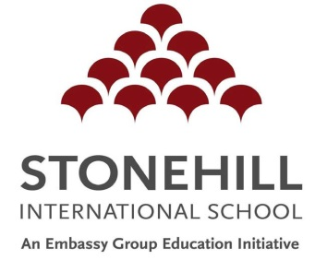
Stonehill International School
259 / 333 / 334 / 335
Tarahunise Post, Jala Hobli,
Bangalore North 562 157, India

Enquiry: +91 8043418300
Admissions: +91 7026666911
+91 8494922100
admissions@stonehill.in
www.stonehill.in

Attach passport photo of the student

Application for Diploma Programme Academic Scholarship
(2019-20)

Please type or write in black ink. Complete every section of the form and sign on the last page. Attach a copy of the student’s last two years of academic reports.

Name of Candidate:

(Forename) (Middle Name) (Surname)
Gender:

Current School: Current Grade:

Current Curriculum:

Date of Birth: Age:
(Date/Month/Year)
Name of Parent/ Guardian:

Residential Address:

Mobile Number: Email:

Name of Employer/ Business:

Employer’s Address:

1. I would like to apply for a scholarship for my child for the following program:

Grade 11 (D1) – 16 years old by Sept 1, 2019 (Max age limit – 17 years)

2. I hereby certify that I am not currently employed by a company that reimburses my child’s school fees.

Name of Parent/ Guardian:

Date: Signature:

Candidate to complete:
1. Explain in a personal statement why you would like to study at Stonehill International School. How will IB education help you achieve your goals? (350-500 words)

(The Personal Statement may be typed and attached.)

2. During the Diploma Programme, you will have to write an Extended Essay (Research Paper) of 4000 words on a topic of your choice. Outline your extended essay (research paper) proposal in 500 words.

(The proposal may be typed and attached.)

