2017-2018

Please sen d this form by POST to: (Administrative office)

2nd Floor, Cecil Court, Near Regal Cinema, Mahakavi Bhushan
Road, Colaba, Mumbai – 400 039. India.
  - ail: info@nathanitrust.org Website: www.nathanitrust.org
Telephone: 022-6122 6122

Time: 10:30 am-1:30 pm. To2:30- 5:30 pm (Monday to Friday)
•Application Form should be filled in ENGLISH Only.
•Application Form should be filled in BLOCK LETTERS
•Applicant should write in the boxes
•Applicant should write neat handwriting using Ball Pen only
•Incomplete Form will not be considered
•Applicant should AFFIX his/her LATEST PHOTOGRAPH
•No Double Form should be filled and sent by an Applicant

Continued Scholar’s Application Form

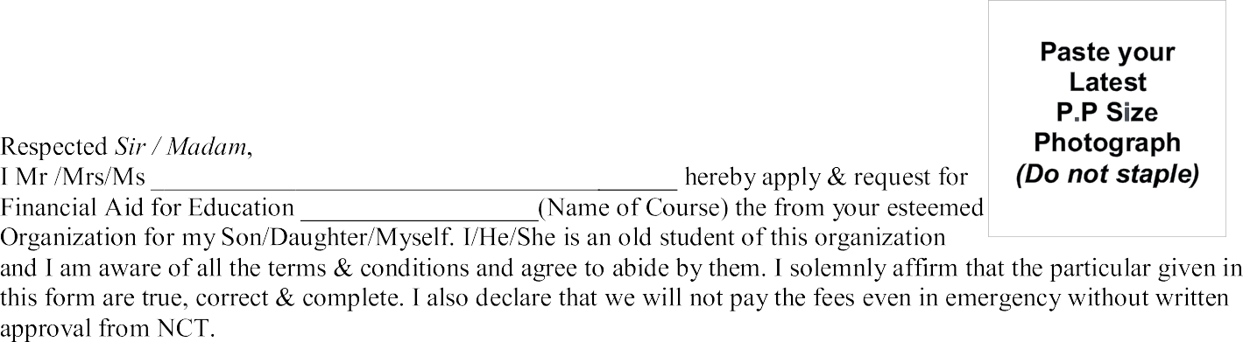

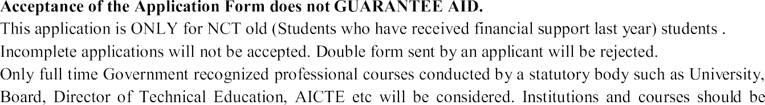

    - Ths Student will be given scholarship on the basis of Aptitude, Intelligence Quotient (IQ), Interest, Personality
Test results.
    - Please note Aptitude, Intelligence Quotient (IQ), Interest, Personality test is to guide the student for best career option. Aptitude testing does not GUARANTEE of SCHOLARSHIP.

Page - 1

Expired: YES/NO If Yes Date Of Expire
DD/MM/YYYY
Expired: YES/NO If Yes Date Of Expire
DD/MM/YYYY

Student Contact Address(If student is staying at any other location not mentioned) and Contact Number

*Permanent Address :

Deenyat Course

Have you attended any basic course of deenyat suggested by NCT: Yes
No
Course Name: Madresa Details: .
Any other course Please Specify: .

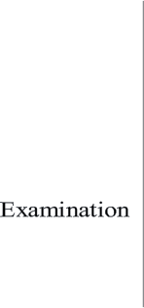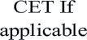
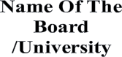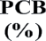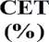Page - 2

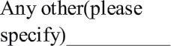

Page - 3

